Lab 1: Exploring Cloud Virtualization

and Data Center Architecture

Name : Mazen Yasser

Group : SE2

Student Submission
This report includes screenshots from the completed lab and answers to the required questions.

Part A: VMs vs Containers
Container observations (Docker Desktop screenshot):
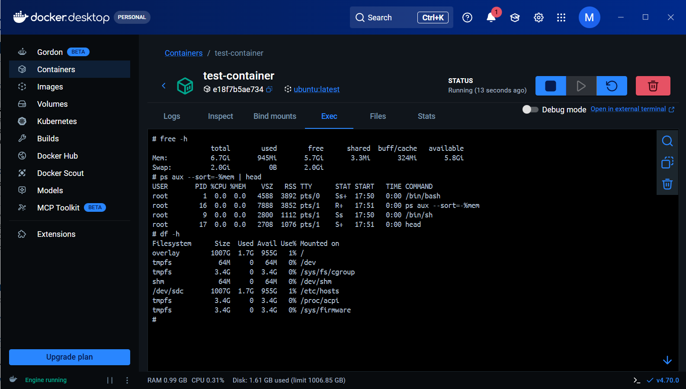

VM observations (Ubuntu VirtualBox screenshot):
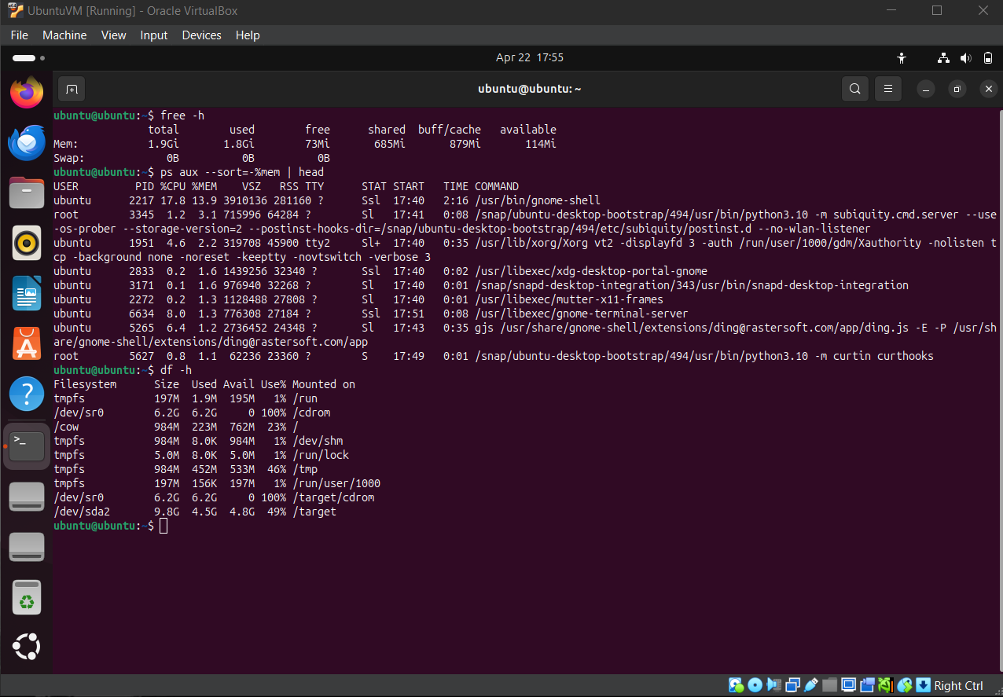
Comparison Summary:
- Startup Time: Containers start in seconds, while VMs take longer because a full OS must boot.
- Memory Usage: The container used about 945 MiB with 5.7 GiB free on host resources shown. The VM with 1.9 GiB RAM had about 1.8 GiB used, showing higher overhead.
- Process Count: Containers run fewer processes and share the host kernel. VMs run many OS background services.

Part B: Cloud Infrastructure Exploration
AWS account screenshot:
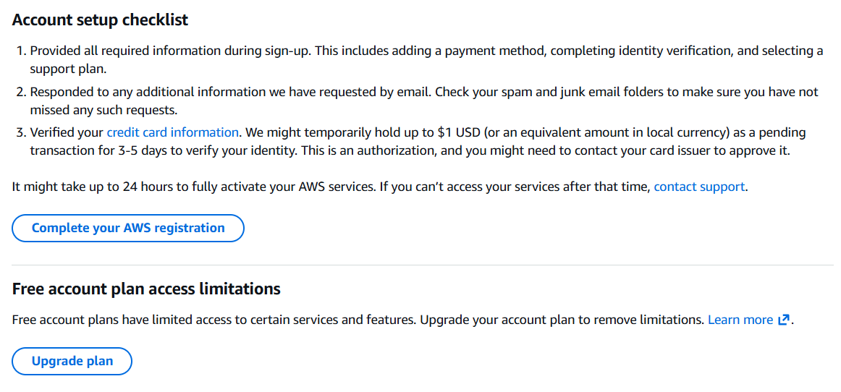

Part C: Tail Latency Mini-Simulation
ApacheBench result screenshot:
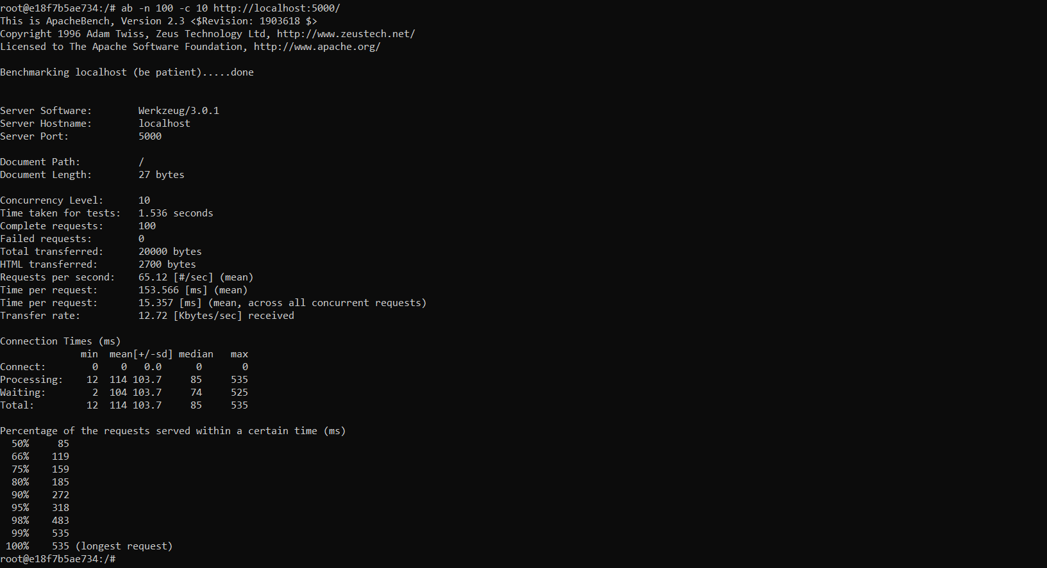

Observation: Most requests completed quickly, but a small number were much slower. This demonstrates tail latency.

